|  |
| --- |
| Circle Language Spec: Commands |

## Parameters in a Command Definition in a Diagram

This article demonstrates a situation of command objects.

This article illustrates how parameters in a command definition look in a diagram. The diagram below displays an inactive command definition with parameters:

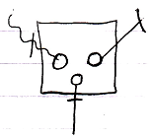

The square is a command definition. The circles inside of it are the parameters. The rest of what’s visible in the diagram are the parameter passings. Parameter passings are explained in the *parameter* articles. The parameter passings are the lines connected to the circles, that are marked with an access mark.